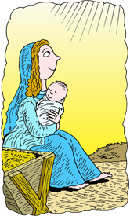
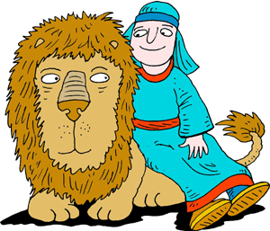
People of the Bible
Q | N | F | B | V | D | J | D | B | Q | I | V | N | C | W
D | A | W | Y | Q | D | L | O | Z | H | Z | W | E | R | F
I | H | E | P | M | S | E | P | S | J | O | H | N | H | V
V | T | E | L | I | J | A | H | R | E | M | G | V | N | A
A | A | I | I | R | U | K | E | U | Y | P | A | O | A | B
D | N | Y | L | L | J | T | N | I | A | C | H | R | D | E
L | O | K | K | O | E | X | A | C | F | B | A | X | Y | L
N | J | T | S | P | A | X | Z | P | H | F | F | K | E | K
Z | S | I | A | H | S | I | L | E | J | T | P | I | L | R
J | A | S | T | G | B | W | C | H | O | Z | U | E | G | A
H | M | S | W | J | V | T | J | D | B | U | I | R | A | M
K | U | T | U | A | N | O | A | H | P | N | E | E | P | G
E | E | O | S | S | O | N | B | A | A | K | R | K | O | D
P | L | A | G | W | E | D | I | D | U | Q | B | X | N | S
Z | W | N | J | G | N | J | Q | L | G | J | E | Q | M | E

ABEL | CAIN | DANIEL
DAVID | ELIJAH | ELISHA
GOD | JESUS | JOB
JOHN | JONATHAN | JOSEPH
JOSIAH | LUKE | MARK
MARY | NOAH | PAUL
PETER | RUTH | SAMUEL

