Christmas

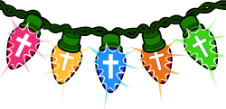

P | D | M | Y | J | D | O | R | E | H
E | C | A | E | P | W | V | A | M | T
F | L | S | Y | L | I | F | E | F | K
D | U | A | Y | R | S | H | I | Y | R
S | L | B | G | R | E | G | N | A | M
K | A | I | B | L | M | D | T | H | A
B | N | V | H | P | E | S | O | J | R
G | G | T | I | C | N | H | J | G | Y
R | E | H | T | O | M | B | I | R | C
B | L | F | H | T | R | I | B | F | M

ANGEL | BABY | BETHLEHEM
BIRTH | CHILD | CRIB
GIFT | GOD | HAY
HEROD | JESUS | JOSEPH
LIFE | MANGER | MARY
MOTHER | PEACE | SAVIOR
STAR | VIRGIN | WISEMEN

